NETFLIX CONTENT ANALYSIS DASHBOARD
Data Storytelling & Statistical Validation
Prepared By:
Yuva Teja
Institution:
KIET
Date:
June 12 2026

- Introduction
Netflix is one of the world's largest streaming platforms. This project analyzes the Netflix dataset to understand content distribution, production trends, ratings, and geographical distribution. The project uses Python for data analysis, Power BI for visualization, and statistical testing for validation.
- Dataset Description
Attribute | Description

show_id | Unique content ID

type | Movie or TV Show

title | Content title

country | Country of production

rating | Content rating

release_year | Release year

duration | Duration

listed_in | Genre

Total Records : 8809
Movies : 6131
TV Shows : 2676

- Dashboard Analysis

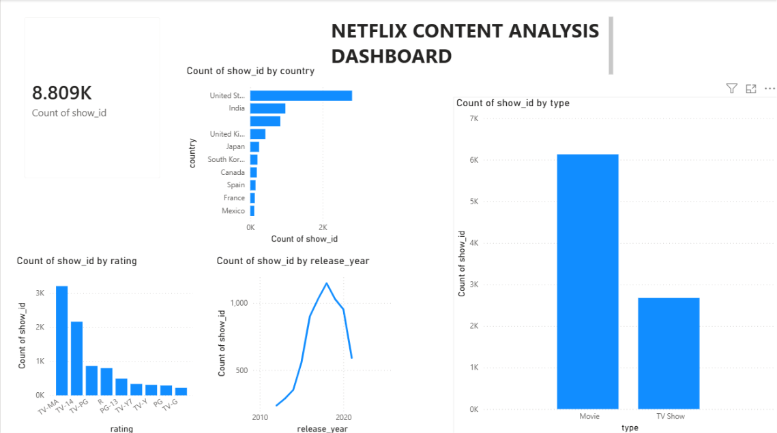

Key Findings:
- Movies dominate Netflix content.
- TV Shows are fewer.
- United States contributes the highest content.
- India is the second largest contributor.
- TV-MA is the most common rating.

- Country Analysis
The United States produces the highest amount of Netflix content. India ranks second, followed by the United Kingdom and Japan.
- Rating Analysis
TV-MA is the most frequently occurring rating category, indicating that Netflix primarily targets mature audiences.
- Release Year Analysis
Netflix content production increased significantly after 2015 and peaked around 2019 before declining.

- Statistical Validation

Null Hypothesis (H₀)
Movies and TV Shows are equally distributed on Netflix.

Alternative Hypothesis (H₁)
Movies and TV Shows are not equally distributed on Netflix.

Observed Values:
Movie = 6131
TV Show = 2676

Expected Values:
4403.5
4403.5

Chi-square Statistic:
1355.40

P-value:
1.03 × 10^-296

Interpretation:
Since the p-value is significantly less than 0.05, the null hypothesis is rejected. Therefore, the distribution of Movies and TV Shows on Netflix is statistically different.
- Business Recommendations
• Continue investing in movie production.
• Expand TV show production.
• Increase regional content offerings.
• Focus on audience-preferred ratings.
• Use data-driven content strategies

- Conclusion

The analysis reveals that Netflix's catalog is heavily dominated by movies. The United States remains the largest content producer, while content production peaked around 2019. Statistical testing confirms that the difference between Movies and TV Shows is significant.

